Project
  - Deadline: Phase 1 (Mid project Progress Report) 26/07/2026 @ 23:59 Phase 2 (Final project Report) 9/8/2026 @ 23:59
[Total Mark is 20]

System Analysis and Design
IT-353

Instructions:
- You must submit two separate copies (one Word file and one PDF file) using the Assignment Template on Blackboard via the allocated folder. These files must not be in compressed format.
- It is your responsibility to check and make sure that you have uploaded both the correct files.
- Zero mark will be given if you try to bypass the SafeAssign (e.g. misspell words, remove spaces between words, hide characters, use different character sets, convert text into image or languages other than English or any kind of manipulation).
- Email submission will not be accepted.
- You are advised to make your work clear and well-presented. This includes filling your information on the cover page.
- You must use this template, failing which will result in zero mark.
- You MUST show all your work, and text must not be converted into an image, unless specified otherwise by the question.
- Late submission will result in ZERO mark.
- The work should be your own, copying from students or other resources will result in ZERO mark.
- Use Times New Roman font for all your answers.
Student Details: CRN:
Name: fatma alsaokhan  Name:  Name:  Name:  Name: |  | ID: s200095074  ID:  ID:  ID:  ID:

Project submission guidelines and instructions
- Mid project Progress Report:
Students are required to submit a short mid progress report, which must include:
  - Work completed this period
  - One key decision has been made during this period
  - One problem encountered
  - Plan to do next.
  - Each group member input/participation.
  - A link to each group member GitHub repository
- Version History / Commit Log Requirements:
Each group member must complete and submit project history/timestamp using a live, editable GitHub link. The repository must show commit history reflecting incremental progress. commit regularly (at minimum once per week), with clear, descriptive commit messages.
A separate section in the report must be added and named “Project Artifacts" to include each student’s name and a link to his/her GitHub repository (with commit history).
What NOT to do: Students must not write their report elsewhere and paste the final version in at the last minute. They also should not make a single commit containing your entire files. Both are treated as red flags regardless of the quality of the final work.
- Written Reflection (End of Project Report):
The project report should include a Reflection section (300–500 words) as the last section (one section for each student). This section must be written in students’ own words and should address some of the following:
  - Describe one specific challenge or obstacle you encountered during this project and explain in detail how you identified and resolved it.
  - Explain why you chose your specific approach/method/model over at least one alternative you considered, and what tradeoffs informed that decision.
  - If you used any AI tools during this project (e.g., ChatGPT, Claude, Copilot), disclose which tool(s), for what specific purpose (e.g., debugging, grammar checking, brainstorming), and how you verified or modified the output.
  - What would you do differently if you were to redo this project with more time or resources?

Important Notes
- AI use: Students may use AI tools (ChatGPT, Claude, Copilot, Gemini, etc.) only for brainstorming approaches, debugging small errors, or proofreading text. AI must not be used to generate analysis, write code logic, or produce substantial portions of report or codebase. Any permitted AI use must be disclosed in Reflection section. Undisclosed AI use, or AI use beyond this scope (disclosed or not), will result in a zero grade for the entire project.
- Any submission lacking a valid, inspectable version/commit history, or showing evidence of AI generation or plagiarism, will receive a zero grade for the entire project.
- Failure to submit mid progress reports as required, or submission of reports found to be fabricated, copied, or AI-generated, will result in a zero grade for the entire project.

Project Rubric

Component | Weight | Note
Final report/deliverable | 85% | Core assessment of the work itself.
Mid Progress report | 10% | Incentivizes engagement across the timeline, not just at the end. Absence blocks credit for the whole project.
Version/commit history | Pass/fail | Not a grade component. Absence blocks credit for the whole project.
Reflection section | 5% | Rewards demonstrated understanding and honest disclosure.

Scenario

The Saudi Electronic University (SEU) currently organizes a wide variety of extracurricular activities, including workshops, seminars, competitions, volunteering opportunities, social events, career development sessions, and sports activities. However, information about these activities is scattered across emails, social media platforms, and announcements, making it difficult for students to discover upcoming events and register for them. Activity organizers also face challenges in managing registrations, tracking attendance, monitoring participation limits, and preparing reports.
Learning Outcome(s):
Illustrate most common analysis and design techniques in the form of a group project.

To address these issues, SEU plans to develop a Student Activities Management System (SAMS) that will provide a centralized platform for managing all student activities. The proposed system should allow students to browse available activities by category, campus, or date, view detailed information about each activity, reserve a seat, cancel a reservation before the registration deadline, receive notifications and reminders, and record their attendance by scanning a QR code or using another electronic attendance method at the event. Students should also be able to view their personal activity history throughout their studies, including the number of activities attended, participation hours, certificates earned, and achievements. Upon graduation, the system should automatically generate a comprehensive Student Activity Report (Activity Transcript) summarizing all extracurricular activities completed during the student's academic journey.
Activity organizers should be able to create, edit, publish, and cancel activities, define participant limits, registration periods, locations (physical or virtual), attendance methods, and eligibility requirements. Organizers should also manage participant lists, approve registrations when required, record attendance, issue participation certificates, and generate reports on attendance rates and student engagement.
The Student Affairs Department should oversee the entire system by managing activity categories, approving activities submitted by organizers, monitoring participation statistics across all university branches, generating institutional reports, and ensuring that each student's activity transcript is accurate and complete before graduation.
The system should also support notifications for registration confirmations, activity reminders, cancellations, and waitlist updates. If an activity reaches its maximum capacity, additional students should automatically be placed on a waiting list and promoted when vacancies become available.
The university expects the new system to improve student engagement, simplify activity management, eliminate manual attendance tracking, and provide accurate records of students' extracurricular involvement throughout their university studies.
Based on the above scenario, complete the following tasks.

1. Introduction and scope of order
The Student Activities Management System (SAMS) aims to standardize the advertising of extracurricular activities and manage their life cycle from creation, accreditation, and publication to registration, attendance, certification, and reporting. The system addresses the dispersion of information between email, communication and advertising, and provides the student with a central channel for review, registration, and follow-up, as well as providing the organizer and the Student Affairs Department with institutional operating and control tools.

1.1 System Objectives
- Increase student engagement by making activities available in a unified platform that can be searched and filtered.
- Facilitate enrollment, capacity, queue, and approvals management.
- Replacing manual attendance with an electronic mechanism such as a QR Code with an audit record.
- Creating an accurate record of the student's hours, certificates, and achievements throughout the study.
- Automatically generate an Activity Transcript upon graduation after the record is validated.
- Providing operational and institutional reports at the activity, branch and university levels.

2.1 Parties and Scope of Liability
Party | Key Responsibilities
Student | Browse activities, register and cancel, receive notifications, check attendance, view history and testimonials, and activity detection.
Activity Organizer | Create, modify, publish and cancel the activity, adjust capacity, duration, venue and eligibility, manage participants, attendance, testimonials and reports.
Student Affairs Administrator | Manage rankings, approve activities, follow up on branch statistics, corporate reports, and pre-graduation verification.
Graduation System | Request to create or verify the activity statement at graduation procedures.
Notification Service | Deliver registration confirmations, reminders, cancellations, and queue updates.

2. First Task: Gantt Chart of the Project
Schematic Assumption: The duration of the project is 16 school weeks, and the start of the first week is measured without assuming an unstated calendar date. The numbering of the dependencies in the table matches the order of the activities.
Number | Activity | Duration | The Beginning | Accreditations
1 | Requirements Collection | One week | Week 1 | —
2 | System Analysis | One week | Week 1 | 1
3 | Choosing a prototype method | One week | Week 1 | 2
4 | Architectural System Design | One week | Week 1 | 2
5 | Design of Primary Screens | One week | Week 2 | 3
6 | Context and Level-0 DFD Setup | One week | Week 2 | 2
7 | Level-1 DFD Charts | One week | Week 2 | 6
8 | Use Case Model | One week | Week 2 | 2
9 | Activity Diagrams | One week | Week 2 | 8
10 | Class Diagram | One week | Week 2 | 4
11 | Database Design and Normalization | One week | Week 2 | 10
12 | Review and Integration | One week | Week 2 | 11
13 | Preparation of the Final Report | One week | Week 2 | 12
14 | Review & Delivery | One week | Week 2 | 13

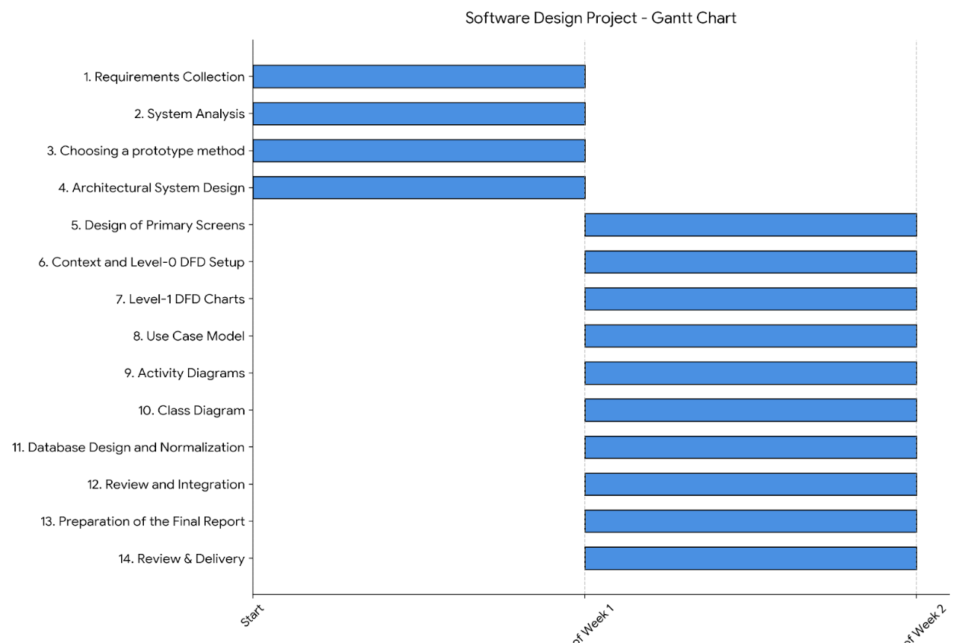
Figure 1: Proposed Gantt Chart for the SAMS Project over a 16-Week Period

2.1 Dependencies logic
- Gathering requirements precedes analysis because models and processes must be built on a clear scale.
- The design of the screens depends on the choice of prototype style and architectural design.
- Level-1 charts rely on the completeness of the Context Diagram and Level-0 so that the boundaries of operations and data stores remain consistent.
- Class Diagram takes advantage of processes and use cases, and then becomes a direct input to database design.
- Integration and final review begin only after all forms have been completed; the report is prepared and delivered.

3. Task Two: Prototype

3.1 Method chosen: Evolutionary Prototyping
Evolutionary Prototyping was chosen because SAMS is a multi-party system and contains operational rules that may become increasingly clear, such as eligibility requirements, approval of enrollment, student transition from the waitlist, and proof-of-attendance controls. This approach allows for the construction of a simplified prototype and then its development on sequential courses based on feedback from students, organizers, and student affairs management, while retaining the proven parts rather than disposing of them entirely.

3.2 Why is it best suited for the project?
- Different usage needs exist between the student, the organizer, and the administration, and they can be tested early.
- The ease of browsing, recording, and scanning QR needs actual user experiences before final installation.
- Wait, capacity, and approvals rules are adjustable when new real-world cases are detected.
- The model can be gradually transformed into a workable product with improved design, security, and performance in each version.
- It reduces the risk of building an entire system and then discovering that the registration or attendance steps are not suitable for users.

3.3 Proposed evolution cycle
Course | Scope | Verification Output
Session 1 | Browse activities, filtering, and details | Test the activity's findability and understanding of its information.
Session 2 | Registration, Cancellation and Queue | Test grammar, messages, and fillings.
Session 3 | QR , attendance and certifications | Accuracy testing, speed of proof of attendance, and exception handling.
Session 4 | Reports and Activity Disclosure upon Graduation | Assembly validation and institutional verification.

Screen Design
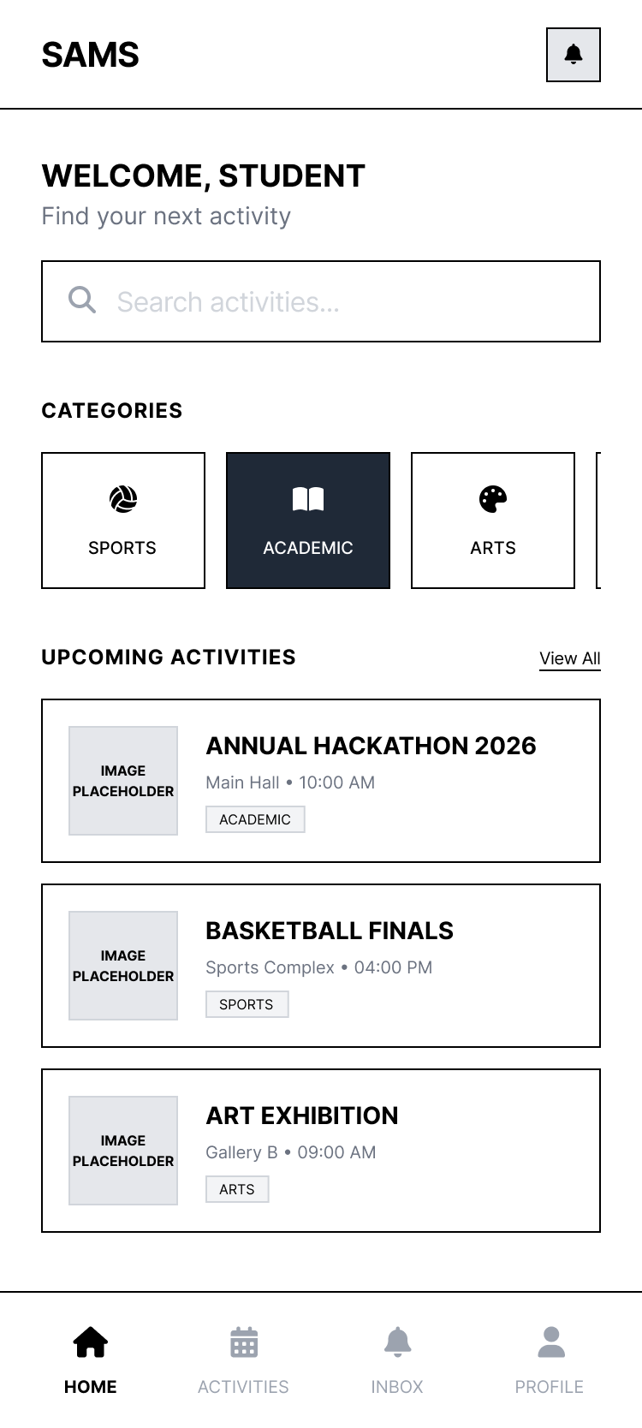
Figure 2: Low-resolution homepage model
Page
Screen Design
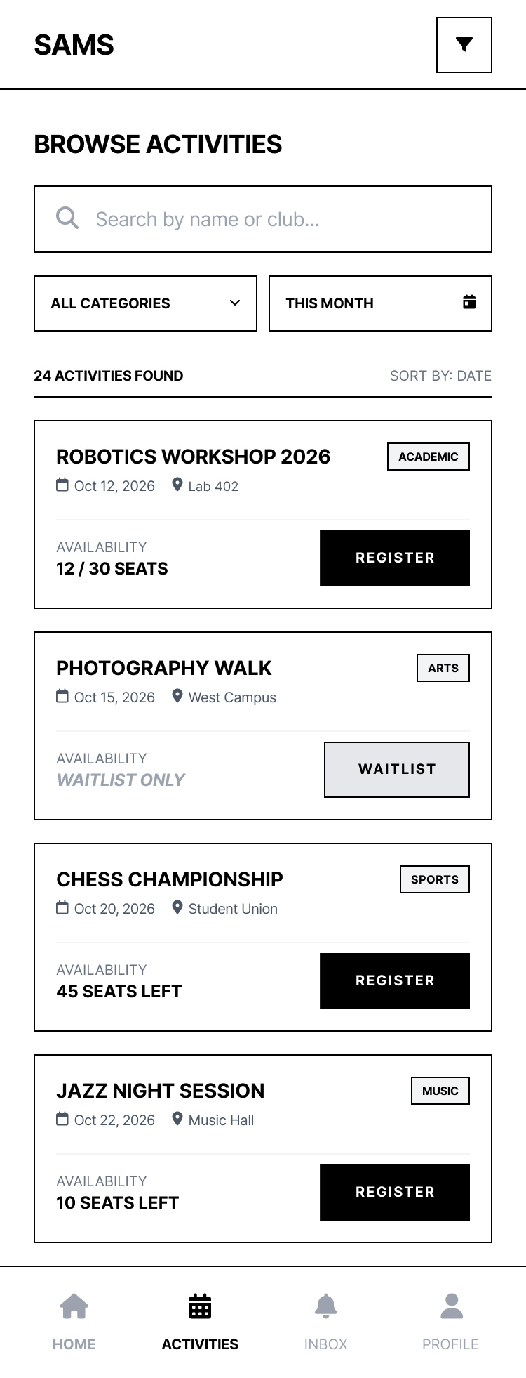
Figure 3: Low-resolution model of the activity browsing screen
Screen Design 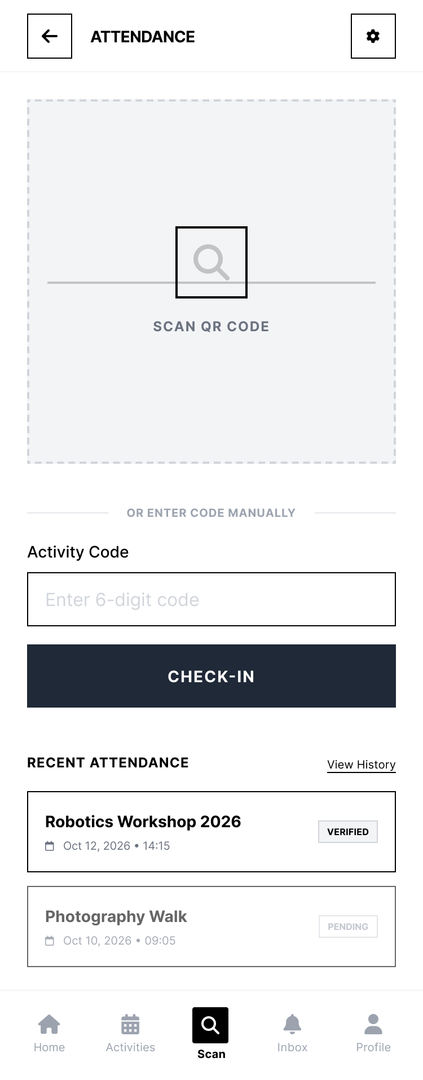

Figure 4: Low-resolution model of recording and attendance screen

3.4 Usability Notes
- Clearly show registration status, capacity, and end of the period before confirming the booking.
- Use a uniform label for statuses: Draft, Pending, Published, Closed, Canceled, Completed.
- Provide specific error messages when you are ineligible or close registration instead of a public message.
- Separate the attendee's QR from the booking code or number, with a time window specified for verification.
- Support access from the phone because registration and attendance often happen on the go.

4. Task Three: Data Flow Charts (DFDs)
The following charts use third-parties, processes, and data stores while maintaining the principle of balancing: Inflows and outflows in the Context Diagram are detailed and consistent in Level-0 and then in Level-1.

4.1 Context Diagram
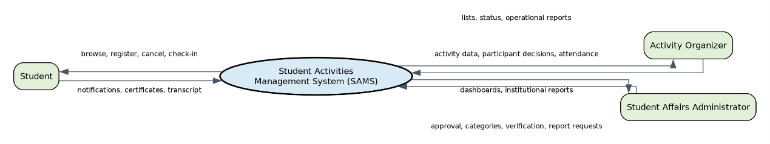
Figure 5: Context Diagram for SAMS

The system appears as a single process that exchanges data with the student, the activity organizer, and the student affairs department. The notification service and the graduation system are represented in the use case model as they are technical integrations, while in the Context Diagram it focuses on the primary human actors sending and receiving business data.

4.2 Level-0 DFD
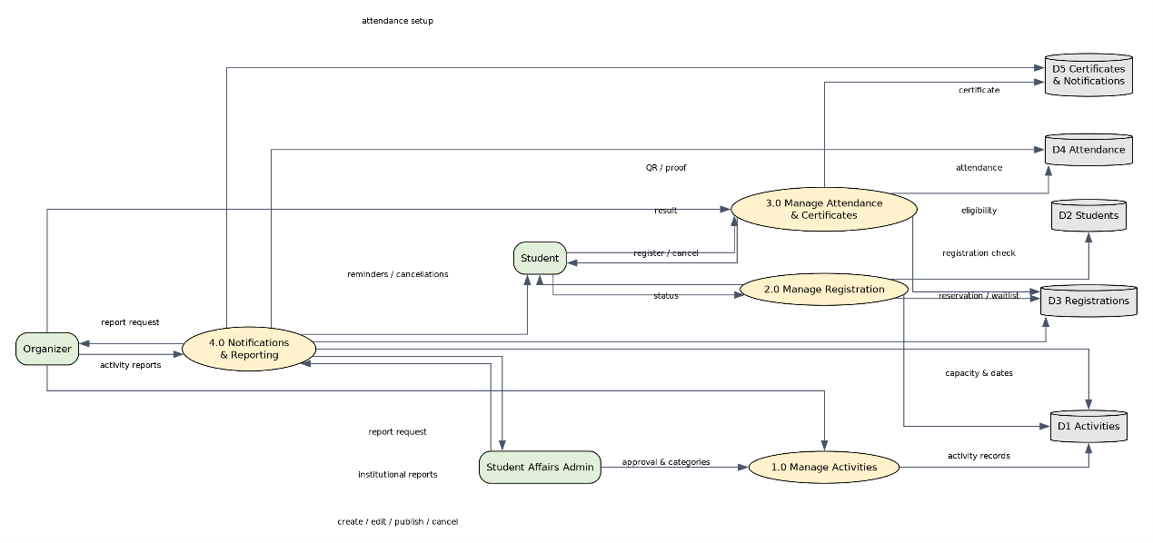
Figure 6: Level-0 DFD and the Four Main Processes

Operation Number | Operation Name | Description | Core Data Stores
1.0 | Activity Management | Create, verify, approve, publish, or cancel the activity. | D1 Activities
2.0 | Registration Management | Eligibility and capacity check, reservation, cancellation, and waitlist. | D1, D2, D3
3.0 | Attendance and Certification Management | Preparing the means of attendance, verification, registration, and issuance of certificates. | D3, D4, D5
4.0 | Notifications and Reports | Send messages and compile activity, branch, and university reports. | D1, D3, D4, D5

4.3 Level-1: Activity Management
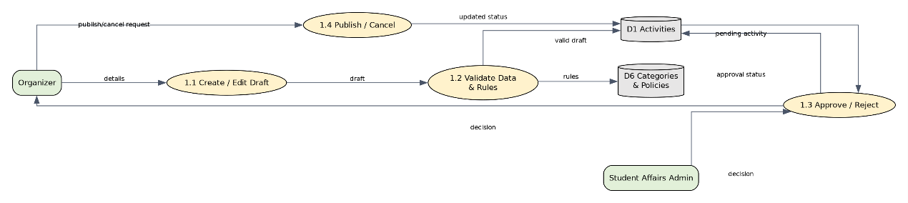
Figure 7: Level-1 for Process 1.0 Activity Management
- 1.1 Create/edit a draft: Collects title, description, classification, branch, time, capacity, location, and rules.
- 1.2 Verification of data and rules: Publication is prohibited in the absence of mandatory fields or date conflicts.
- 3.1 Adoption/Rejection: Management records the decision and comment and returns the status to the regulator.
- 1.4 Post/Cancel: Changes the status of the activity and triggers relevant notifications.

4.4 Level-1: Student Registration
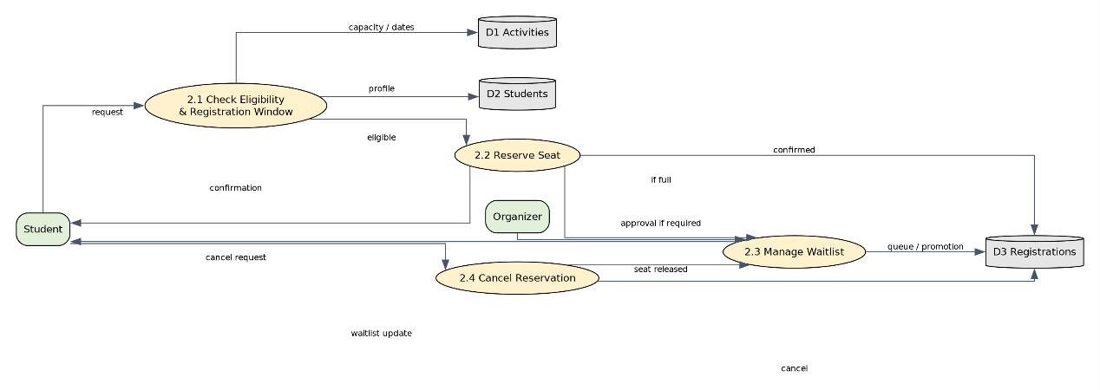
Figure 8: Level-1 for Process 2.0 Registration Management
- 2.1 Examination of the registration period, eligibility and duplicate registration.
- 2.2 Seat reservation when capacity is available, with pending approval status if the activity requires approval.
- 2.3 Manage the queue in a fixed order according to the time of joining, and automatically transfer the first student when a seat is available.
- 2.4 Cancel the booking before the end of registration and launch the upgrade process from the waiting list.

4.5 Level-1: Attendance Management
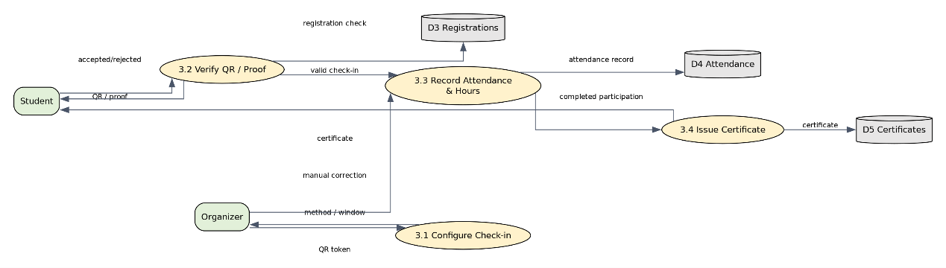
Figure 9: Level-1 of Process 3.0 Attendance Management and Certifications

- 3.1 The Organizer specifies the means of attendance and its time window and generates the session code.
- 3.2 The system verifies the validity of the QR and the confirmed student registration and non-repetition.
- 3.3 Attendance time, method, status and hours of participation shall be saved, with authorized manual adjustment when required.
- 3.4 Issue a certificate associated with completed registration and certified attendance.

4.6 Brief Data Dictionary
Data Element | Content
Activity Data | Title, Description, Category, Branch, Date & Time, Style, Location/Link, Capacity, Registration Period, Hours, Status.
Registration Request | student_id, activity_id, time of order, approval status, booking or waiting status.
Attendance Proof | registration_id, Session Code, Scan Time, Attendance Method, Verification Result.
Activity Record | Activities attended by the student, hours, certificates, achievements, status of verification.
Report Request | Time Range, Branch, Classification, Activity, Attendance and Participation Indicators.

5. Task Four: Use Case Model

5.1 All Actors
Actor | Type | Floor
Student | Basic | Searches, records, cancels, confirms attendance, and reviews the record and certificates.
Activity Organizer | Basic | Manages activity, participants, attendance, testimonials, and operational reports.
Student Affairs Administrator | Basic | Manages rankings, accreditation, statistics, and pre-graduation verification.
Graduation System | External secondary | Request or verify the Activity Transcript within the Graduation Procedure.
Notification Service | External secondary | Performs sending mail, messages, or notification within the app.

5.2 Use Case Diagram
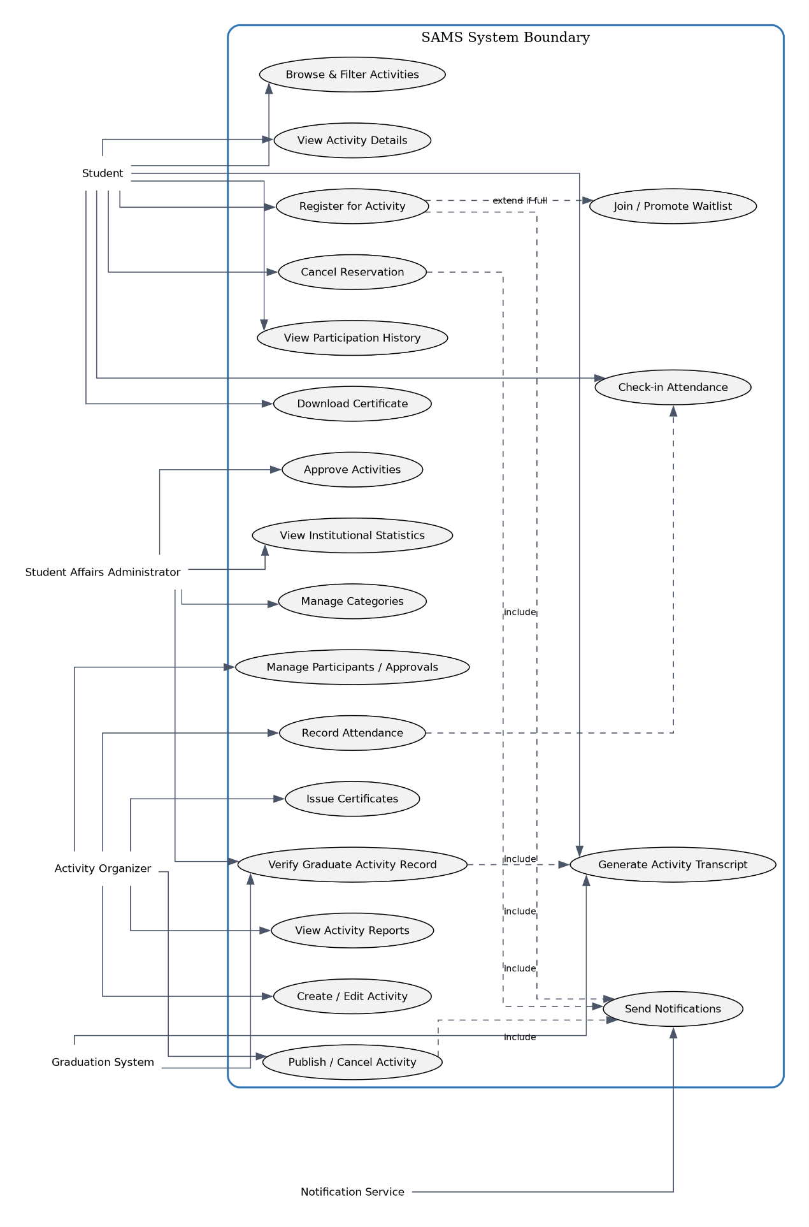

Figure 10: Complete SAMS Use Case Diagram

5.3 doucment Use Case 1: Register for Activity
The field | Documentation
Name | Register for Activity — Register for an Activity
Objective | Reserve a seat for a student in a qualifying and available activity, or add it to the waiting list when full.
Actor | Student; the Activity Organizer may intervene when approval is required .
Prerequisites | The student is logged in and his account is active; the activity is published; the registration period is open.
Catalyst | The student presses the button to book a seat.
Main scenario | 1) The order displays the details. 2) The student requests registration. 3) The system checks the eligibility, non-repeatability and period. 4) Check the capacity. 5) Creates a Registration with a status of Confirmed or Pending Approval. 6) Updates the number and sends the confirmation.
Alternative scenario | A1: Not eligible or closed period: The application is rejected with the reason. A2: Activity is full: Creates a waitlisted and saves the queue. A3: Needs Approval: Pending Approval remains until the regulator's decision. A4: Previous Recording: Prevents repetition.
The end result | Correct saved registration, sender notification, capacity consistency or queue position.

5.4 Use Case 2: Cancel Reservation
The field | Documentation
Name | Cancel Reservation
Objective | Enable the student to cancel his/her reservation within the allowed time and make the seat available to the first waiting student.
Actor | Student
Prerequisites | The student is logged in, has a revocable registration, the cancellation /registration period has not ended.
Catalyst | The student chooses to cancel the reservation and confirms the decision.
Main scenario | 1) The system retrieves the registration. 2) Checks for cancellation. 3) Changes the status to Cancelled and records the time. 4) Releases the seat. 5) The first eligible student is selected in the queue and transferred automatically. 6) Sends two notifications.
Alternative scenario | A1: Timed out: Refuses to cancel and shows the reason. A2: No waiting student: The seat remains available. A3: The first student who is no longer eligible: exceeds it according to a documented policy and takes the next test with the audit record kept.
The end result | Cancel Saved ; Capacity Updated; Queue Updated; Notifications Recorded.

5.5 Use Case 3: Create Activity
The field | Documentation
Name | Create Activity — Create Activity
Objective | Create a completed activity draft and submit it for approval before publishing.
Actor | Activity Organizer , Student Affairs Administrator.
Prerequisites | The organizer is logged in and authorized; active classifications and branches are available.
Catalyst | The organizer chooses to create a new activity.
Main scenario | 1) The organizer enters the basic data. 2) Determines capacity, enrollment period, style, location, attendance, and eligibility. 3) The system checks the fields and dates. 4) Saves the draft. 5) Sent by the organizer for approval. 6) The system records the Pending Approval status and notifies the administration.
Alternative scenario | A1: Incomplete data or invalid dates: identifies errors and does not allow transmission. A2: Location or Time Conflict: Displays a warning or denies depending on the policy. A3: Admin Rejection: Draft is re-submitted with comment for modification and resubmission.
The end result | Activity is saved with a unique ID and a valid status, with a traceable credential record.

6. Task Five: UML Activity Diagrams

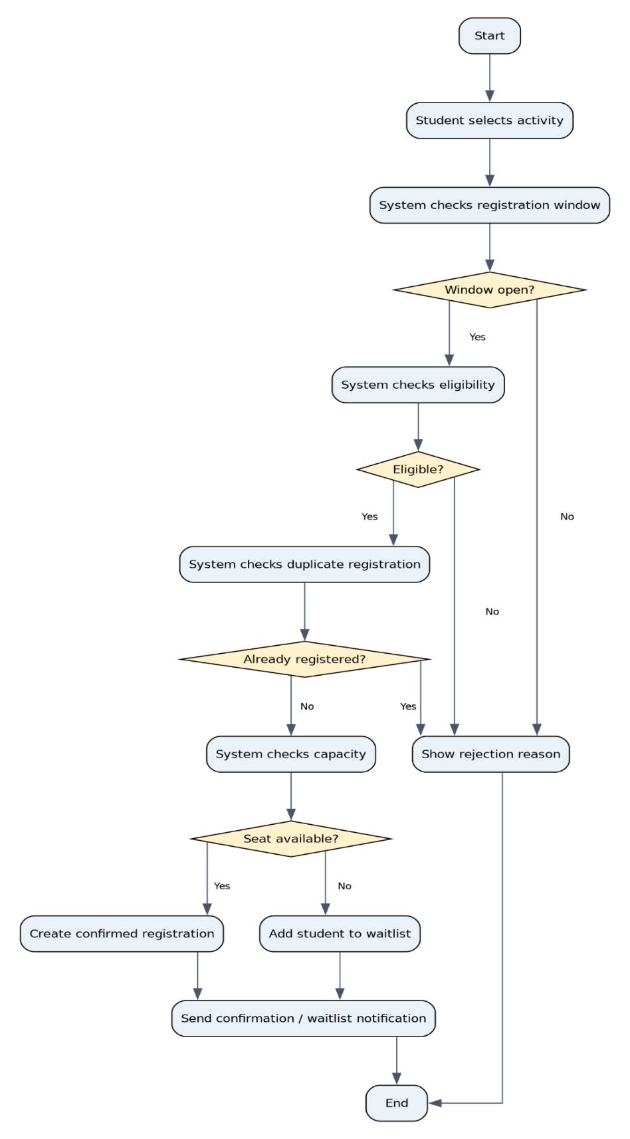
6.1 Student Registration in the Activity

Figure 11: Activity Diagram for Student Registration in the Activity
The chart shows the decision points that prevent incorrect registration: enrollment window, eligibility, non-recurrence, and capacity availability. If a seat is not available, the flow moves to the queue instead of rejecting the student directly.

6.2Attendance Registration with QR Code
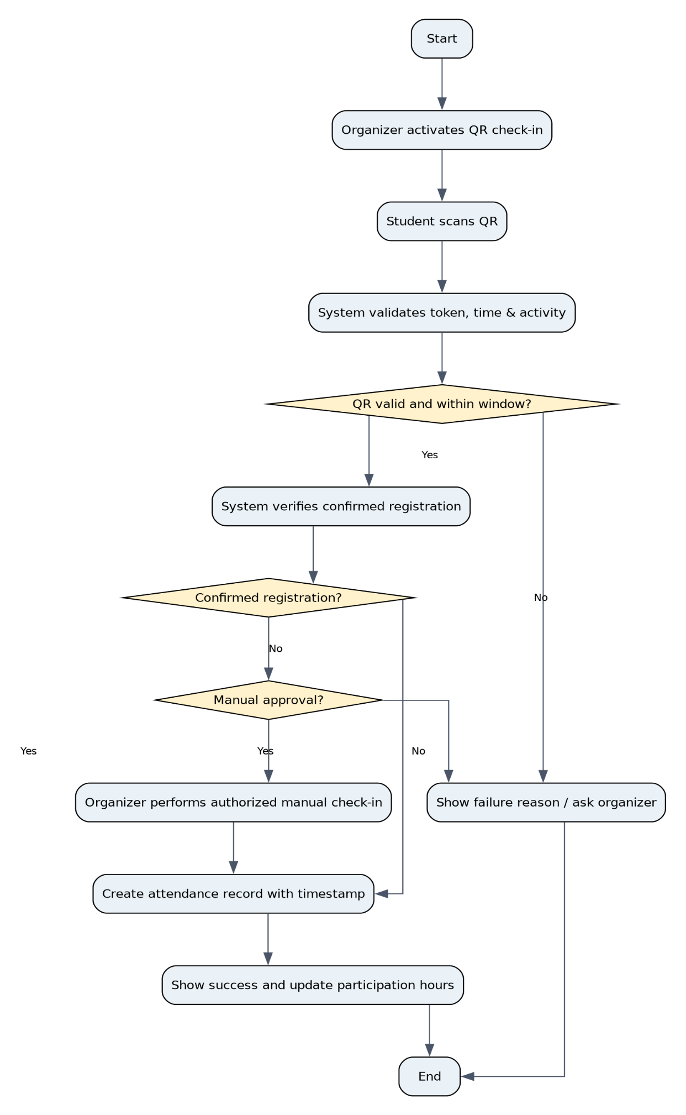
Figure 12: Activity Diagram for Attendance Recording by QR Code
The validity of the code and time window is verified and the attendees are linked to a confirmed registration. The swing route provides an authorized manual procedure for the regulator in exceptional cases, while the recording remains in the audit log.
Page

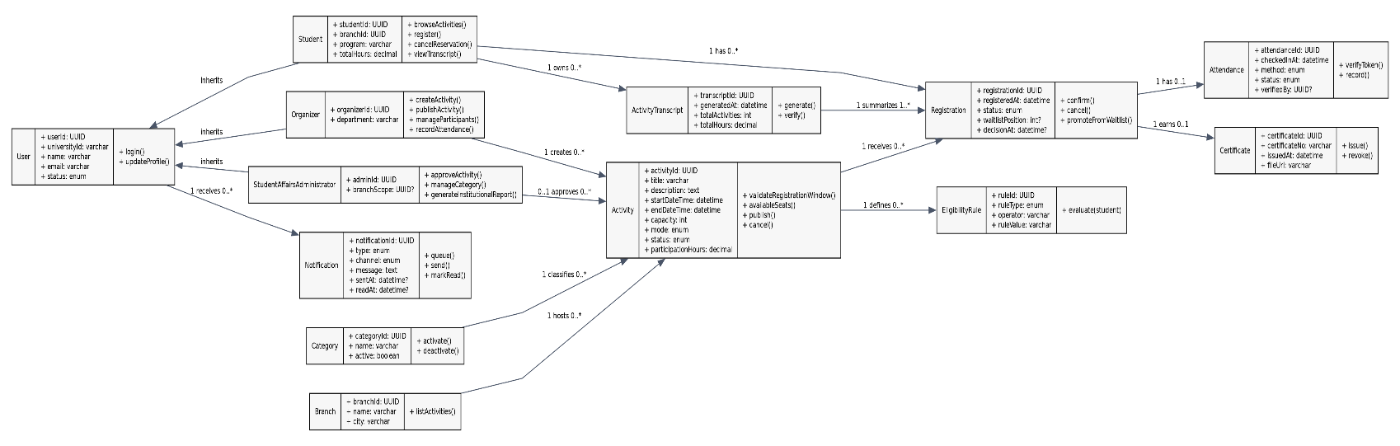
. Task Six: UML Class Diagram

Figure 13: Class Diagram for SAMS

7.1Classes and relationships explained
Class | Responsibility | Main Relationships
User | Stores shared account information and provides authentication for all system users. | Superclass of Student, Organizer, and Student Affairs Administrator.
Student | Registers for activities, cancels registrations, records attendance, and views activity history. | One Student can have 0..* Registrations and 0..* Notifications.
Organizer | Creates and manages activities, participants, and attendance records. | One Organizer can manage 0..* Activities.
Activity | Represents an activity with its details, rules, capacity, and current status. | Associated with one Category, one Branch, multiple Registrations, and multiple Eligibility Rules.
Registration | Links a student to an activity and stores the registration status such as Confirmed, Pending, Waitlisted, or Cancelled. | Each Registration may have 0..1 Attendance and 0..1 Certificate.
Attendance | Records attendance details including the attendance time, method, and verification status. | Each Attendance record is linked to exactly one Registration.
Certificate | Represents the certificate issued after successful participation in an activity. | Each Certificate is linked to one eligible Registration.
Notification | Stores messages sent to users and may be related to a specific activity. | Each User can receive 0..* Notifications.
ActivityTranscript | Represents a summary of the student's completed activities, attendance, certificates, and participation hours. | Generated from completed Registrations, Attendance, and related activity records.

7.2 Limitations of the Domain Model
- Confirmed registrations may not exceed the capacity of the activity.
- A unique restriction on (student, activity) prevents effective duplicate enrollment.
- Attendance is only created for an existing registration, and a certificate is issued only after a completed and approved attendance.
- The waitlistPosition is NULL for the non-Waitlisted state, and is unique within the activity when you use it.
- User inheritance reduces the duplication of identity information, while subtables save the characteristics of roles.

8. Task Seven: Database Design

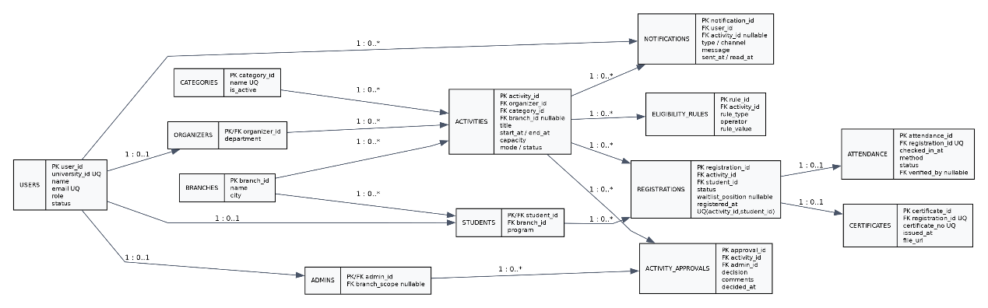
8.1 General relational model

Figure 14: Proposed logical ERD for SAMS database

8.2 Tables, Keys, and Data Types
Table | Fields and Keys | Purpose
BRANCHES | branch_id UUID PK; name VARCHAR(120) UQ; city VARCHAR(100); is_active BOOLEAN | University Branches Data.
USERS | user_id UID PK; university_id Versar, 30, UK; Versace (150); Email Versace (254) UK; Roll Versher (30); Status Versace (20); created_at Timestamp | Shared account of roles.
STUDENTS | student_id UUID PK/FK→USERS.user_id; branch_id UUID FK→BRANCHES; program VARCHAR(120) | Characteristics of the student.
ORGANIZERS | organizer_id UUID PK/FK→USERS.user_id; department VARCHAR(150) | Characteristics of the regulator.
STUDENT_AFFAIRS_ADMINS | admin_id UUID PK/FK→USERS.user_id; branch_scope UUID NULL FK→BRANCHES | Powers of the Administration.
CATEGORIES | category_id UUID PK; name VARCHAR(100) UQ; description VARCHAR(500) NULL; is_active BOOLEAN | Activity Classifications.
ACTIVITIES | activity_id UUID PK; organizer_id UUID FK; category_id UUID FK; branch_id UUID NULL FK; title VARCHAR(200); description TEXT; start_at TIMESTAMP; end_at TIMESTAMP; registration_start TIMESTAMP; registration_end TIMESTAMP; capacity INT; mode VARCHAR(20); venue VARCHAR(250) NULL; virtual_url VARCHAR(500) NULL; attendance_method VARCHAR(30); requires_approval BOOLEAN; participation_hours DECIMAL(5,2); status VARCHAR(30); created_at TIMESTAMP | Activity and lifecycle data.
ELIGIBILITY_RULES | rule_id UUID PK; activity_id UUID FK→ACTIVITIES; rule_type VARCHAR(50); operator VARCHAR(10); rule_value VARCHAR(250) | Expandable eligibility rules.
REGISTRATIONS | registration_id NEW PK; activity_id UUID FK; student_id UUID FK; registered_at TIMESTAMP; status VARCHAR(30); waitlist_position INT NULL; decision_by UUID NULL FK→USERS; decision_at TIMESTAMP NULL; cancelled_at TIMESTAMP NULL; UQ(activity_id,student_id) | Booking, approval, waiting, and cancellation.
ATTENDANCE | attendance_id UUID PK; registration_id UUID UQ FK→REGISTRATIONS; checked_in_at TIMESTAMP; method VARCHAR(30); status VARCHAR(20); verified_by UUID NULL FK→USERS; evidence_ref VARCHAR(500) NULL | One proof of attendance per registration.
CERTIFICATES | certificate_id UUID PK; registration_id UUID UQ FK→REGISTRATIONS; certificate_no VARCHAR(80) UQ; issued_at TIMESTAMP; file_url VARCHAR(500); status VARCHAR(20) | Certificates.
NOTIFICATIONS | notification_id UUID PK; user_id UUID FK→USERS; activity_id UUID NULL FK→ACTIVITIES; type VARCHAR(40); channel VARCHAR(20); message TEXT; queued_at TIMESTAMP; sent_at TIMESTAMP NULL; read_at TIMESTAMP NULL; status VARCHAR(20) | Notifications and reminders.
ACTIVITY_APPROVALS | approval_id NEW PK; activity_id UUID FK; admin_id UUID FK; decision VARCHAR(20); comments VARCHAR(1000) NULL; decided_at TIMESTAMP | Record of accreditation decisions.
TRANSCRIPT_SNAPSHOTS | transcript_id NEW PK; student_id UUID FK; generated_at TIMESTAMP; total_activities INT; total_hours DECIMAL(7,2); verification_status VARCHAR(20); verified_by UUID NULL FK→USERS; file_url VARCHAR(500) NULL | Official copies generated upon request; details derived from recordings and attendance.

8.3 Proposed Restrictions and Indexes
Page
- CHECK (capacity > 0) CHECK (end_at > start_at) CHECK (registration_end >= registration_start).
- CHECK (participation_hours >= 0) and constraints for the values allowed in status , mode, and method.
- UNIQUE(activity_id, student_id) in REGISTRATIONS to prevent duplicate registration.
- UNIQUE(registration_id) in ATTENDANCE and CERTIFICATES to ensure a relationship of 1 to 0..1.
- Composite index of ACTIVITIES(status, start_at, category_id, branch_id) to speed up browsing.
- REGISTRATIONS INDEX(activity_id, status, waitlist_position, registered_at) to support capacity and upgrade.
- Perform a queue dialer transfer within a Transaction with a proper lock to prevent the same seat from being reserved simultaneously.
- Encrypt the session link or QR code and not store a reusable secret value in its raw form.

8.4 Normalization Implementation Up to Third Normal Form (3NF)
Stage | Problem Before Normalization | After Normalization
1NF | An activity could store multiple participants or eligibility rules in a single field. | Each field stores only one value. Participants are stored in the REGISTRATIONS table, and eligibility rules are stored in the ELIGIBILITY_RULES table.
2NF | In a combined table containing both student and activity data, some attributes depend only on the student or only on the activity. | Student and activity information are stored in separate tables. The REGISTRATIONS table is used to connect students with activities.
3NF | Activity records may contain repeated information such as branch names, category names, or organizer details. | This information is stored in separate tables and linked using foreign keys, which reduces redundancy and keeps the data consistent.

Example 3NF: In ACTIVITIES activity_id defines all activity properties. category_name is not stored in ACTIVITIES because category_id specifies the name within CATEGORIES. Also, branch_id the branch name and city are specified in BRANCHES, there is no transition dependency activity_id → branch_id → branch_name within the activity table.

8.5 Business Rules to Implement in the Service Tier
- DYNAMICALLY COUNT THE NUMBER OF CONFIRMED SEATS FROM REGISTRATIONS INSTEAD OF STORING AN ASYNCHRONOUS COUNTER; IF USING A PERFORMANCE OPTIMIZATION COUNTER, IT SHOULD BE UPDATED ATOMICALLY.
- When canceling: Select the first Waitlisted enrollment by waitlist_position and then registered_at, recheck eligibility, and upgrade it within a single transaction.
- Create an Activity Transcript from recordings that have Attendance approved, then count the number and hours and attach certificates—save an official snapshot only when needed.
- Maintain a record of critical approvals and adjustments for institutional review purposes.
- Hide data by role and branch and apply the principle of less validity.

9. Consistency and tracking between models
Class / Database | DFD / Use Case | Key Requirement
Activity, Category, Branch / ACTIVITIES, CATEGORIES, BRANCHES | Process 1.0: Browse Activities | Activity Browsing
Registration / REGISTRATIONS | Process 2.0: Register, Cancel, Waitlist | Registration & Queue
Attendance / ATTENDANCE | Process 3.0: Check-in | E-Attendance
Certificate / CERTIFICATES | Process 3.0: Issue Certificate | Certificates
Notification / NOTIFICATIONS | Process 4.0: Send Notifications | Notifications
Administrator / ACTIVITY_APPROVALS | Process 1.3: Approve Activities | Activity Approval
ActivityTranscript / TRANSCRIPT_SNAPSHOTS | Generate Transcript | Activity Transcript

10. Conclusion
In this project we created a solid foundation for developing the SAMS system as a centralized and scalable platform We linked the analysis and design phases and used the evolutionary prototype approach to reduce usability issues Then we converted the system requirements into data flow diagrams use cases behavioral diagrams class diagrams and the database design
Before starting the implementation we need to define the eligibility policies cancellation periods branch permissions and data retention rules We also need to test scenarios with many users such as capacity management queue handling and electronic attendance to make sure the system works efficiently

